Conceptual games and activities for teaching times tables
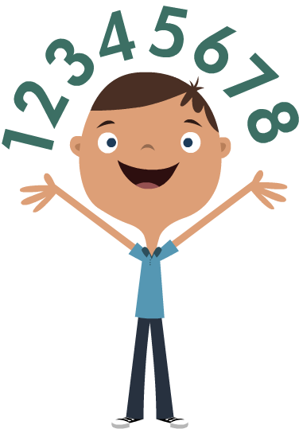

2019
In this booklet are the activities and games which promote a more “conceptual” approach to teaching times tables. They are based on understanding the connections and patterns in the tables facts – repeated addition, the inverse and presentation of the tables facts as arrays of different types.
There are some “stand alone” games and several which use the card set as the main resource. Please use a range of these games each week. Multiple activities should be set up to run simultaneously in your class so groups will be engaged in different activities at any one time. You should ensure your pupils access a variety of games through each week.
When using the 'conceptual' materials resources, a range should be accessed each week. The cards are for the conceptual materials.
- children will require a 10 or 12 sided dice (or just use two six-sided die) for the pepperoni pizza game; for Year 3 please affix stickers for appropriate times tables
- use 6-sided dice for the How Close to 100? game
Before using the cards and games
You might introduce the cards by choosing one tables fact and showing the class that we can see that fact in different ways, for instance as:
The straightforward multiplication sentence - 3 x 7
The same sentence reversed – 7 x 3
The product - 21
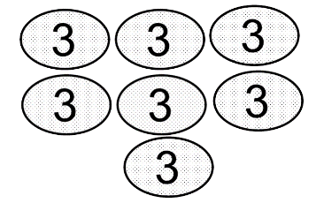
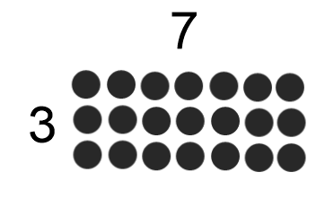
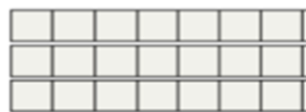
The inverse – 21 ÷ 3 / 21 ÷ 7
An array -

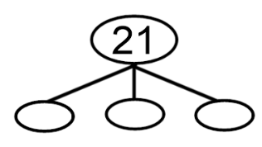
A “part – whole” model -

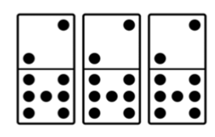
Repeated addition – 7+ 7 + 7 / 3 + 3 + 3 + 3 + 3 + 3 + 3
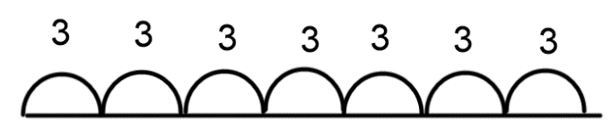

Once they understand that they need to “connect the ideas” in order to match cards, you can start slowly by using cards for just a couple of tables facts in the same table in one of the snap games below.

- Using the cards should be very flexible and adaptable to your class.
- You can use some or all of one table.
- You can use just the easier or just the “tricky” facts for one table.
- You can mix just the easier facts or just the harder facts for different tables.
- You can carefully select the facts that your particular group are having trouble with.

Using the Cards
You can use the cards in a lot of straightforward “Snap!” type games and you can adjust the difficulty and the number of tables that you are covering by using different sets of cards. Please feel free to make up your own snap type or other games with the cards.
Snap!
Use a table set (e.g. the 3x table set) or two or three or a combination, making sure that you have the six cards for each tables fact.
As they become more proficient, you might only use the tables facts from the three tables that they are finding tricky.

- In a group of four, children each have a pile of cards face downwards in front of them. Starting with the first child, they each place one down on a pile in the middle. When a child sees that the one that they have is the same as the one last put down on the pile, they say Snap! They say why the two are the same (“3 rows of 4 are the same as 4 x 3”, “8+8+8 is the same as 24”). They take both cards. If they place it on the pile without noticing that the two are the same but another child sees that they are, as soon as the card is let go, they shout Snap! and claim the cards if they can say why they are the same. Everybody should agree why they are the same. The winner is the one with the most cards at the end.

- The cards are all placed face downwards in the middle. In turn, each child takes a card and places it on a pile face up. If the card they pick matches the last one, they say Snap! They say why the two are the same (“3 rows of 4 are the same as 4 x 3”, “8+8+8 is the same as 24”). They take both cards. If they place it on the pile without noticing that the two are the same but another child sees that they are, as soon as the card is let go, they shout Snap! and claim the cards if they can say why they are the same. Everybody should agree why they are the same. The winner is the one with the most cards at the end.


- Each child is dealt 5 cards. The rest are placed in the middle. One by one, the cards in the middle are turned over. If the turned over card matches to one that a child has in their hand, s/he shouts Snap, explains why they are the same and claims the cards. When they have claimed the cards, they take the next one from the top of the pile to replace the one they have paired. Play continues until all of the cards have been matched. The winner is the child with the largest number of cards. A variation is that they don’t pick up a new card and play continues until one player has matched all five of their cards.

- Each child is given a tables fact or a number (this can be more difficult as some numbers are products in more than one table). They turn over cards from the middle pile and take ones that match to their tables fact or number. They have o say why they match. The winner is he one to get all of the five other cards that match the tables fact.

Measles
Stick the cards up around the room randomly. Give each child a tables fact. They have to run and collect the cards that match that tables fact and bring them back to their table. When they have done so, they must convince their partner / group that all of their cards match.

Find someone who
Each child has a card. They walk around the room and find someone who has a card that shows the same tables fact. When they agree that the cards are the same, they come to the teacher / TA and explain why. Then they can either be given new cards or asked to sit down, depending on how long you want the activity to last.

Inside / Outside Circle
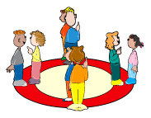
Children form two circles, one inside the other (with one child facing out and one facing in). They compare their cards. If they match, they shout Match! and explain why. If none match, the outside circle (or the inside) moves round one place. Are there any matches now? They move around until they have all seen each- others’ cards. When they match two cards, they take another two from the central pile or that pair might sit down.
They might compete - one group (two circles) against another. When they match two cards, they take another two from the central pile. The winning group is the one that matches the cards in the pile first.

Other conceptual games / activities

Pepperoni Pizza
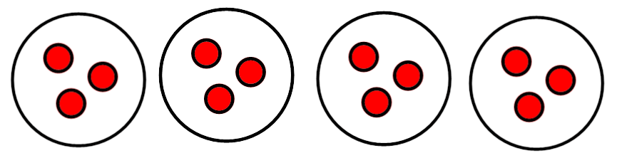

In this game, children roll a dice twice. The first roll tells them how many pizzas to draw. The second roll tells them how many pepperonis to put on EACH pizza. They answer the question, “How many pepperonis in total?”
For example, I roll a dice and get 4 so I draw 4 big pizzas. I roll again and I get 2 so I put two pepperonis on each pizza. I then count how many pepperonis all together and say “four lots of 2 equal eight” (It’s important to do the saying part!)

To make the game specific to a table e.g. 3s, 4s and 8s, you can either set the number of pizzas e.g. 3 and roll the die once or put stickers on blank dice e.g.3,4 and 8 or whatever table you want to focus on and use a 6 die for the other so you can roll e.g. 6 lots of 4/8/3. If you want to extend the range of the times table that you are working on, you can use for instance a 9 die or a 12 die.

Bucket and ring.
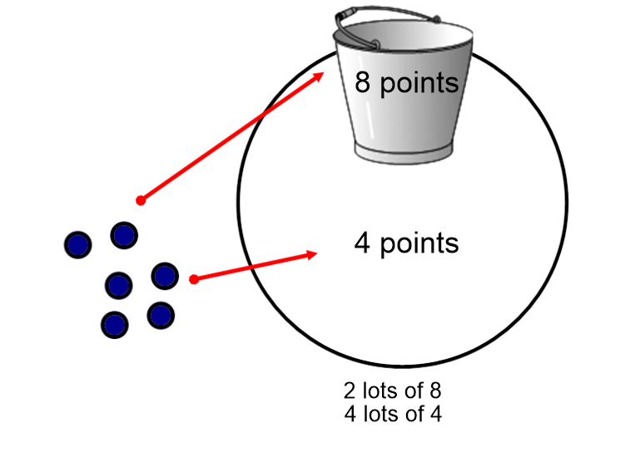
Put a bucket or other container inside a ring (This can be a hoop or just a ring made from string). Each player has 6 bean bags. A bean bag thrown into the bucket is worth 3, 4, 8 etc points (whichever tables you are working on). A bean bag that misses but goes in the ring is worth 2, 3, 4 etc (but less than the bucket score).
When they have thrown all of their bean bags, they should count their score by repeatedly adding the scores for the individual bean bags e.g. saying 8 and 8 and 8 ,…. or “3 lots of 8 equals 24”
You might use red cubes and blue cubes and a tub on the table.
It’s important to do the saying part!
How close to 100?
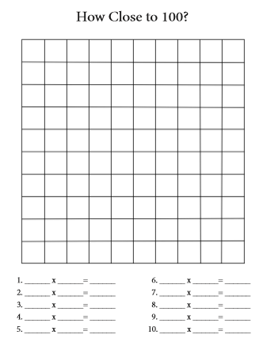
This game is played in partners. Two children share a blank 100 grid. The first partner rolls two number dice. To make the results specific to particular times tables, you will need to “doctor” a die with small stickers or write on a blank die (depending on which table/s you are concentrating on). The numbers that come up are the numbers the child uses to make an array on the 100 grid e.g. 3 x 6. They can put the array anywhere on the grid, but the goal is to fill up the grid to get it as full as possible. After the player colours the array on the grid, s/he writes in the number sentence that describes the grid. The second player then rolls the dice, draws the number grid and records their number sentence. The game ends when both players have rolled the dice and cannot put any more arrays on the grid. How close to 100 can you get?

Variation
Each child can have their own number grid. Play moves forward to see who can get closest to 100.

Tables orienteering

In orienteering, children are given a map with points marked on it (A, B, C etc). At those points, you attach the blue squares (“controls”). They match the lettered square on their map with the one in real life and go there. On the blue square is attached a photocopy of one of the tables cards (You might laminate them if using outside).

When they find the control and the card attached to it, they write down on the recording sheet the tables fact that they find there (use the ones with graphics rather than the actual tables facts). They leave the controls in place.

You might start off in groups and work down to pairs and individuals.

You can specify the order in which the controls are found or not. One group might start with A and another with B and another with C etc.

You can also do it as a relay – one child or pair goes and finds one, returns and swaps with their partner / partner pair.

You can easily use an average classroom
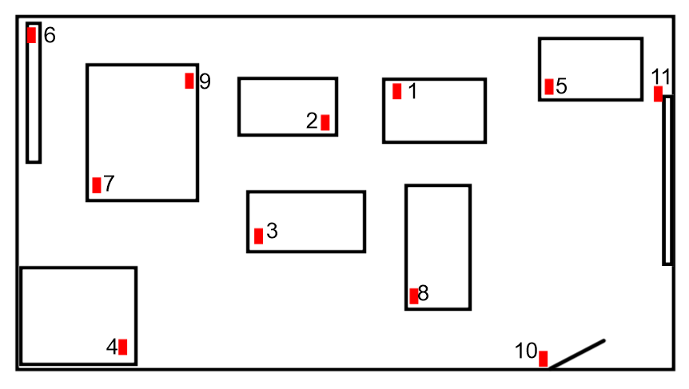

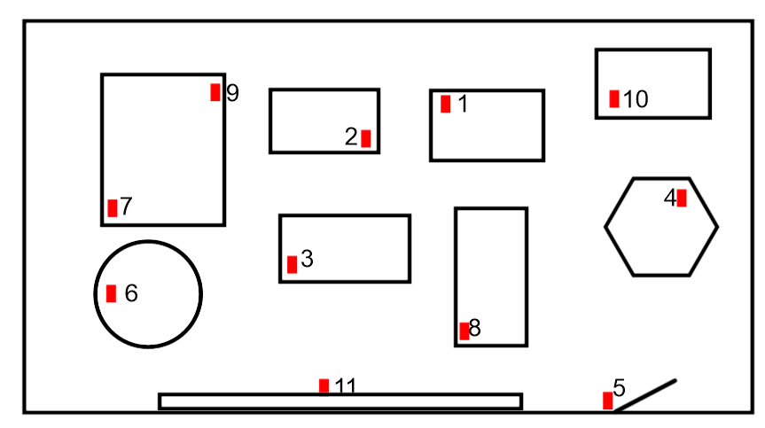

Or mats and equipment in the school hall

Or outside of course!

The materials for orienteering are contained in a separate file.

Image display

Not a game, but you might put a tables square or part of one on the wall with just the numbers on the axes, leaving spaces where the products would usually go. Give children cards to fit into the spaces that show that tables fact as arrays of different types or repeated addition shown in different ways, as on the conceptual cards.

 | 3 | 4 | 5 | 6 | 7 | 8
3
4
5
6

